Measurement System Analysis
How-to Guide - Workbook

Workbook Instructions
Work through each exercise in turn to check understanding. If in doubt please seek assistance. This is not an exam and the results will not be shared with any other person.
You can check your answers at the back of the Workbook in the Answer Booklet.

Contents
- Exercise 1: Identifying Measurement Systems | Page 3
- Exercise 2: Recognising Types of Data | Page 4
- Exercise 3: Understanding Repeatability and/or Reproducibility | Page 5
- Exercise 4: Revision and Understanding Measurement System Analysis | Page 6
- Exercise 5: Operational Definitions | Page 7
- Exercise 6: Understanding Where Variation is Occurring | Page 8
- Exercise 7: Capturing Reasons for Less than Acceptable MSA Studies | Page 9
- Exercise 8: Minitab Analysis | Page 10
- Exercise 9: Minitab Analysis | Page 11

Exercise 1: Identifying Measurement Systems
1.1 Think about your own part of the business & try to note down 5 measurement systems that are used. For each consider:
- What is the thing being measured?
- What does the measurement system comprise of (think about the equipment, people, measurement standards and processes being used plus any environmental factors)
- How confident are you in the reliability of the data from each measurement system?
 | What is being measured? | What is the measurement system? | How confident are you in the reliability of the data?
1
2
3
4
5

Exercise 2: Recognising Types of Data
2.1 For the following descriptions, identify the type of data as Continuous or Attribute (Please tick).
Data Description | Continuous | Attribute
Complaints codes assigned to customer complaints letters
The time taken for a candidate to respond to a job offer
The number of red cars in a car park
The average height of people
The number of expenses claims which are approved
The temperature of a liquid
The weight of a suitcase

Exercise 3: Understanding Repeatability and/or Reproducibility
3.1 For each of the following scenarios decide: whether the problem with the measurement system is one of repeatability or reproducibility (where the data is continuous) or within appraiser agreement or between appraiser agreement (where the data is attribute):
The critical dimension of a machined part is measured in-process by four different operators. All of the operators are asked to measure a representative sample of 10 parts from the process multiple times. All the operators are consistent within themselves in their measurements. However the analysis shows that two of the operators obtain different measurements compared to the other two.
What is the data type?
What is the problem identified with this measurement system?
3.2 The Finance department check every invoice to ensure that it is accurate before sending it to the client. Four clerks were asked to check a sample of 20 invoices, and decide whether each was accurate or not. This was then repeated 2 days later (by the same four clerks, using the same 20 invoices). When the results of the two sets of checks were compared, it was found that one of the clerks reached a different conclusion on the second day than they did on the first, for 7 of the invoices.
What is the data type?
What is the problem identified with this measurement system?
3.3 The quality department review incoming customer complaints and assign a complaint code to each. A sample of 20 complaints letters is taken and Susan and John (two of the quality technicians) review each of the letters and decide which code to assign to it. The results are compared, and for 12 of the letters, John chose a different complaint code to Susan.
What is the data type?
What is the problem identified with this measurement system?
3.4 In the goods despatch area an experiment is done to check the consistency of the package weighing methods. 1 package is weighed multiple times on each of the three sets of scales. Whilst two of the scales consistently reach the same result. The results for the third set of scales show a range of different weights for the same package
What is the data type?
What is the problem identified with this measurement system?

Exercise 4: Revision and Understanding Measurement System Analysis
4.1 What is the purpose of Measurement System Analysis?
………………………………………………………………………………………………..........
………………………………………………………………………………………………..........
………………………………………………………………………………………………………
4.2 What is the definition of a Measurement System?
………………………………………………………………………………………………………
………………………………………………………………………………………………..........
………………………………………………………………………………………………………
4.3 Define what is meant by the Repeatability of a Measurement System?
………………………………………………………………………………………………………
………………………………………………………………………………………………..........
………………………………………………………………………………………………………
4.4 Define what is meant by the Reproducibility of a Measurement System?
………………………………………………………………………………………………..........
………………………………………………………………………………………………………
………………………………………………………………………………………………………
4.5 Define what is meant by With Appraiser Agreement?
………………………………………………………………………………………………..........
……………………………………………………………………………………………………...
………………………………………………………………………………………………………
4.6 Define what is meant by Within Appraiser Agreement?
………………………………………………………………………………………………..........
……………………………………………………………………………………………………...
………………………………………………………………………………………………………

Exercise 5: Operational Definitions
Write an operational definition for each of the following measurements.
5.1 Timing how long it takes to get to work (in minutes).
………………………………………………………………………………………………..........
………………………………………………………………………………………………………
………………………………………………………………………………………………………
………………………………………………………………………………………………………
……………………………………………………………………………………………………...
………………………………………………………………………………………………………
………………………………………………………………………………………………………
5.2 Determining whether the appearance of a small cake is acceptable for sale in a bakery.
………………………………………………………………………………………………..........
………………………………………………………………………………………………………
………………………………………………………………………………………………………
………………………………………………………………………………………………………
……………………………………………………………………………………………………...
………………………………………………………………………………………………………
………………………………………………………………………………………………………
5.3 Determining the weight of a bar of chocolate (in grams)
………………………………………………………………………………………………..........
………………………………………………………………………………………………………
………………………………………………………………………………………………………
………………………………………………………………………………………………………
……………………………………………………………………………………………………...
………………………………………………………………………………………………………
………………………………………………………………………………………………………

Exercise 6: Understanding Where Variation is Occurring?
How would you interpret each of the following components of variation graphs?
6.1
………………………………………………
………………………………………………
………………………………………………
………………………………………………
………………………………………………
………………………………………………
………………………………………………
6.2
………………………………………………
………………………………………………
………………………………………………
………………………………………………
………………………………………………
………………………………………………
………………………………………………
………………………………………………
6.3
………………………………………………
………………………………………………
………………………………………………
………………………………………………
………………………………………………
………………………………………………
………………………………………………
Exercise 7: Capturing Reasons for Less than Acceptable MSA Studies
7.1 Return to your own measurement systems as noted down in exercise 1. What potential reasons could there be for variation? Use the Cause and Effect Diagram to help you list as many causes of measurement system variation as you can.
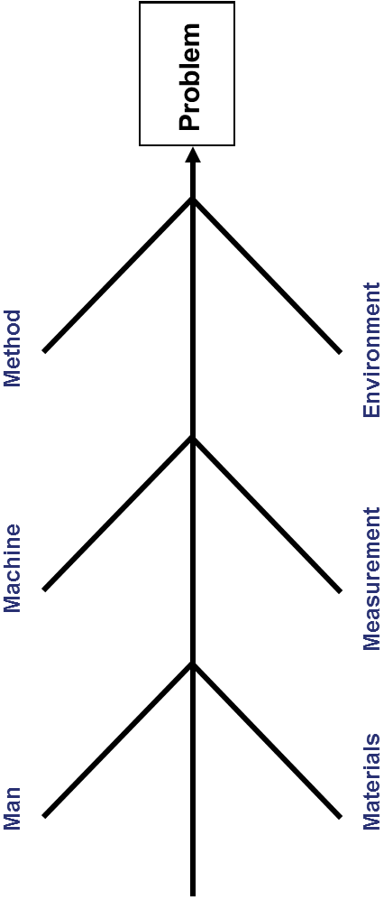
Exercise 8: Minitab Analysis
8.1 The Minitab worksheet ‘Julies Gauge R&R Data 2’ contains the data from the study which Julie and her team did once the improvements had been implemented. Analyse this data following step 4 of the workbook.
What is the % tolerance? Is this acceptable?
………………………………………………………………………………………………
………………………………………………………………………………………………
………………………………………………………………………………………………
………………………………………………………………………………………………
………………………………………………………………………………………………
………………………………………………………………………………………………
………………………………………………………………………………………………
………………………………………………………………………………………………
………………………………………………………………………………………………
………………………………………………………………………………………………
Review each of the graphs in turn and describe what you think it tells you about the measurement system performance.
………………………………………………………………………………………………
………………………………………………………………………………………………
………………………………………………………………………………………………
………………………………………………………………………………………………
………………………………………………………………………………………………
………………………………………………………………………………………………
………………………………………………………………………………………………
………………………………………………………………………………………………
………………………………………………………………………………………………
………………………………………………………………………………………………
………………………………………………………………………………………………

Exercise 9: Minitab Analysis
9.1 The Minitab worksheet ‘After Improvement.mtw’ contains the results of the Attribute Agreement Analysis study which Tom and his team completed after improving the measurement system. Analyse this data (reviewing both the numerical and graphical outputs). Has the performance of the measurement system improved, and if so by how much? Compare the before and after results for Between Appraisers, Within Appraisers and Each Appraiser vs Standard.
………………………………………………………………………………………………
………………………………………………………………………………………………
………………………………………………………………………………………………
………………………………………………………………………………………………
………………………………………………………………………………………………
………………………………………………………………………………………………
………………………………………………………………………………………………
………………………………………………………………………………………………
………………………………………………………………………………………………
………………………………………………………………………………………………
………………………………………………………………………………………………
………………………………………………………………………………………………
………………………………………………………………………………………………
………………………………………………………………………………………………
………………………………………………………………………………………………
………………………………………………………………………………………………
………………………………………………………………………………………………
………………………………………………………………………………………………
………………………………………………………………………………………………
………………………………………………………………………………………………
………………………………………………………………………………………………

Answer Booklet
The following pages show the answers to the exercises within the workbook and should be used for reference and learning points following the completion of the exercises.

Contents
- Exercise 1: Identifying Measurement Systems | Page 13
- Exercise 2: Recognising Types of Data | Page 13
- Exercise 3: Understanding Repeatability and/or Reproducibility | Page 14
- Exercise 4: Revision and Understanding Measurement System Analysis | Page 14
- Exercise 5: Operational Definitions | Page 15
- Exercise 6: Understanding Where Variation is Occurring | Page 16
- Exercise 7: Capturing Reasons for Less than Acceptable MSA Studies | Page 17
- Exercise 8: Minitab Analysis | Pages 17 – 18
- Exercise 9: Minitab Analysis | Page 19

Exercise 1: Identifying Measurement Systems
  - There is no specific answer to this question.

Exercise 2: Recognising Types of Data
2.1
Data Description | Continuous | Attribute
Complaints codes assigned to customer complaints letters |  | x
The time taken for a candidate to respond to a job offer | x
The number of red cars in a car park |  | x
The average height of people | x
The number of expenses claims which are approved |  | x
The temperature of a liquid | x
The weight of a suitcase | x

Exercise 3: Understanding Repeatability and/or Reproducibility
3.1 The data is continuous. Because two of the operators obtain different results from the other two, there is a reproducibility issue.
3.2 The data is attribute. Because the results for one of the clerks differs between the first and second set of checks, there is a within appraiser agreement issue with that particular clerk.
3.3 The data is attribute. As Susan and John chose different complaints codes to each other for some of the letters, there is a between appraiser agreement issue.
3.4 The data is continuous. Because one of the sets of scales does not weigh the same part consistently there is a repeatability issue with this particular set of scales.

Exercise 4: Revision and Understanding Measurement System Analysis
4.1 Measurement System Analysis is used to assess the ability of a measurement system to provide good quality data.
4.2 A Measurement System is the combination of people, equipment, materials, methods and environment involved in obtaining measurements.
4.3 Repeatability assesses whether each person can measure the same item multiple times with the same measurement device and get the same value when measuring continuous data.
4.4 Reproducibility assesses whether different people can measure the same item with the same measurement device and get the same value when measuring continuous data.
4.5 Within Appraiser Agreement assesses whether each person can assess the same item multiple times using the same measurement method and get the same result when measuring attribute data.
4.6 Between Appraiser Agreement assesses whether different people can assess the same item using the same measurement method and get the same result when measuring attribute data.

Exercise 5: Operational Definitions
5.1 The time should be measured using a stopwatch. Before beginning the measurement press the ‘reset’ button and ensure that the display shows 00:00. Start measuring when you close the front door of your house for the final time, by pressing the red button on the top of the stopwatch, and stop measuring when you arrive at your desk, by pressing the red button again. Note the time on the stopwatch in minutes (the first 2 digits) ignoring any seconds shown. For example, 23:47 would be recorded as 23 minutes.
5.2 The sponge cake should have risen above the top of the paper cake case, and the cake must be a similar size and shape to the examples which are shown in the photographs next to the quality inspection station. The icing must be of an even colour, and, must appear to be of even thickness across the full surface of the cake, with no sponge visible underneath the icing. There must be no icing or other marks on the paper cake case. The cherry being used to decorate the cake must be whole and must be in the centre of the cake.
5.3 Using a set of kitchen scales, ensure that the dial on the empty scales shows a reading of zero by adjusting the thumbwheel at the back of the scales. Unwrap the chocolate bar and place it gently on the middle of the scales. Allow 5 seconds for the reading to stabilise and then note the reading to the nearest gram. If the needle on the dial is below the nearest half gram marking, round the weight down to the nearest gram. If the needle is above the nearest half gram marking, round the weight up to the nearest gram.

Exercise 6: Understanding Where Variation is Occurring?
How would you interpret each of the following components of variation graphs?
6.1
We can see that the Repeat bar is tall compared to the Part-to-Part bar, which indicates that there is an issue with Repeatability with one or more of the appraisers.

6.2
We can see that the Gauge R&R and the Repeat and Reprod bars are all small compared to the Part-to-Part bar, which indicates a good measurement system.

6.3
We can see that the Reprod bar is tall compared to the Part-to-Part bar, which indicates that there is an issue with Reproducibility.

Exercise 7: Capturing Reasons for Less than Acceptable MSA Studies
7.1 There is no specific answer to this question.
Based upon delegates own work but should contain several items under each of the main blocks. People, Method, Equipment, Materials etc.

Exercise 8: Minitab Analysis
8.1 We can see from the session window that the %Tolerance is 10.51%, which means that the measurement system is now acceptable. We can also see that the number of distinct categories is now 27, which again indicates that the measurement system is acceptable.

The results of the graphical analysis are summarised in the table below.
Graph | What do we see? | What does this mean?
Components of Variation | Part-part column is the highest. | Most of the variation comes from the parts, not from the measurement system.
R chart by Appraiser | All points very close to zero, very small scale and narrow control limits. | This indicates that there little variation in the measurements.
X Bar Chart by Appraiser | The patterns for all 3 appraisers are very similar. | The appraisers are measuring consistently with each other.
Measurement by Parts | For each part – most of the circles on top of each other or overlapping (with the exception of part 9). | Consistent measurements for all parts (with the exception of part 9).
Measurement by Appraiser | Connecting lines are horizontal and spread of results is similar for all appraisers. | Appraisers are consistent with each other.
Part*Appraiser Interaction | All lines are on top of each pther (i.e. Only one line can be seen) – with the exception of part 9, where there appears to be a slight spread. | Measurement system is consistent, with the exception of part 9, which is slightly less consistent than the other parts. This may be worth investigating, as it may lead to further improvements in the measurement system. See advice from a local Black Belt.
Exercise 9: Minitab Analysis
9.1 As we can see from the ‘After’ results below, all of the %agreement results are now 90% or above, which is an improvement on the results seen before. All aspects of the measurement system are now acceptable (i.e. Within Appraisers, Each Appraiser vs Standard and Between Appraisers all have % Agreement >70%).
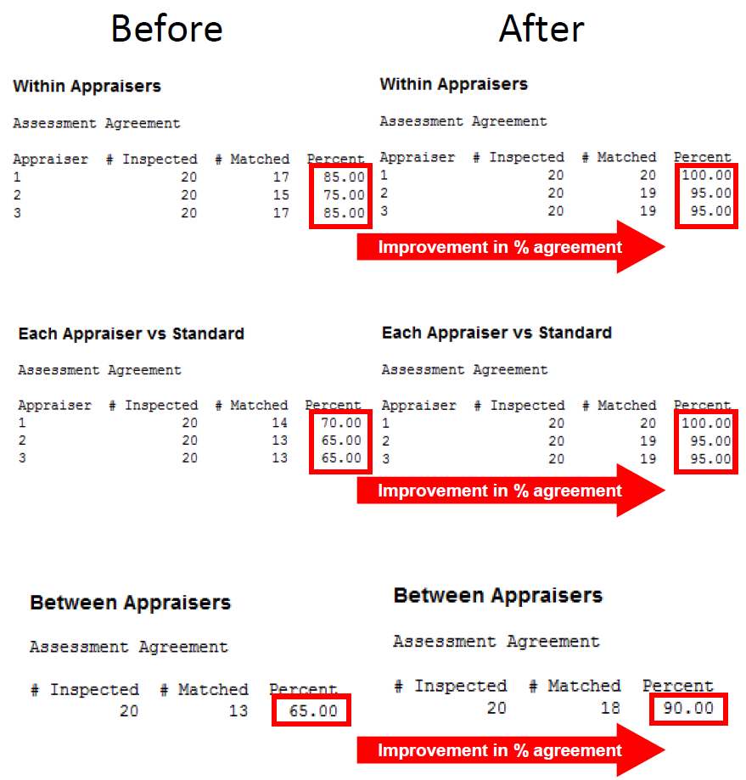

Document Control
Applicability: Global
Title: Measurement System Analysis How-to Guide - Workbook
Author: John Brownell
Document Owner: Mario Martinez
Version Number: 4
Issue Date and Change History: Apr-19

